Armistice Day
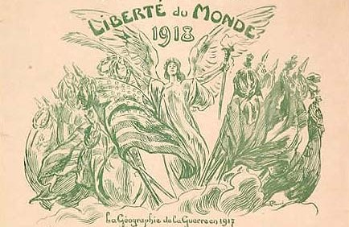
First World War Living History Weekend

Saturday, November 12, 9:30-5:00
Sunday, November 13, 9:30-4:00
Ft. Washington National Park, Ft. Washington, Maryland

On November 11, 1918, World War I came to a close. To commemorate this date, members of the Great War Association will be hosting a “living history” weekend at Ft. Washington National Park in Ft. Washington, Maryland.

Participants representing the armed forces of the United States, Great Britain, France, Belgium, and Germany will be on hand to demonstrate the uniforms and equipment of the first great conflict of the 20th Century. Displays will illustrate how the bright uniforms and tactics from the era of Napoleon that were used at the beginning of the war quickly gave way to the camouflage and modern weaponry that is familiar to us today.

This event is open to the public. There is no admission fee to the park.

